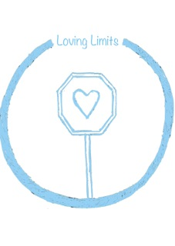 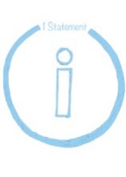

Genevieve Simperingham **www.PeacefulParent.com**

Loving Limits

**Consider needs and wants**

Make a decision about where your wants and needs sit in relation to your child’s wants and needs

**Express the limit**

Express your wants and needs clearly without conflicting messages. Eg “I’d prefer you didn’t … “ is a request, whereas “I can’t let you ... “ is a clear limit.

**Listen**

Truly listen to your child and your heart.  Be flexible if new information comes to light which results in now viewing the limit to not be reasonable, eg you forgot you had promised ….

**Empathise**

Reflect what you hear “I get how hard it is that ... “  Don’t be afraid to elicit disappointment or frustration when you believe that your decision is a good decision.

**Have faith** that with your empathy, listening and care help your child develop greater capacity to feel and move through emotions, increasing self-discipline over time.

*If children can still feel cared for and respected even though they’ve done something wrong or upset their parent, even when their parent holds a limit, they’re gaining the emotional support they need to become a caring and responsible young person who copes with disappointments.*

I decide if my limit is driven by my values and integrity (feels truly right) or my habits and ‘shoulds’.

## Limit, Listen & Empathise

“I know you really want to, but I won’t let you touch the fire, sweetheart. I will keep you safe”

“You wish you could have that toy in the shop. You’re really disappointed that you can’t   
have it.”

**www.peacefulparent.com**

## Consider needs & wants

Know what you want and need

Make a decision about where your wants and needs sit in relation to your child’s wants and needs

## Express the limit

Express your wants and needs in a way that the message was clear,

## Listen

Be flexible when new information comes to light (your child’s thoughts and feelings)

## Empathise

Don’t be afraid to cause your child disappointment or frustration when you believe that your decision was a good decision.

Have faith that your empathy, listening and care was what your child needed even when you are the source of their upset.

Loving Limits

Healing Tears & Tantrums